Concepts, Characteristics, and Models of B2B Ec
Concepts, Characteristics, and Models of B2b Ec ................... 1
4.0 Introduction to B2B EC .......................................................... 1
4.2 The Basic B2B Transaction Types .............................................. 1
4.3 Types of B2B E-Commerce............................................................ 2
4.31 Sell-Side B2B Marketplace Architecture.................................. 2
4.32 Buy-Side B2B Market Architecture............................................ 2
4.4 Barriers to C-Commerce.................................................................. 3
4.5 Infrastructure for B2B........................................................... 3
4.6 Extranet and EDI........................................................................ 3
4.7 Integration ........................................................................... 3
4.71 Integration with existing information systems issues ........................ 4
4.72 Integration with business partners .................................................... 4
4.8 The Role of XML in B2B Integration........................................... 4
4.9 The Role of Software Agents........................................................... 4
4.10 Agent’s role in the buy-side marketplace ..................................... 4

4.0 Introduction to B2B EC
Business-to-business e-commerce (B2B EC) refers to transactions between businesses conducted electronically over the Internet, extranets, intranets, or private networks; also known as eB2B (electronic B2B) or just B2B.It has the following characteristics
1. Parties to the transaction include an online intermediary; that is, an online third-party that brokers a transaction between a buyer and a seller, buyers; sellers
2. It has two main types of transactions namely:
Spot buying which involves the purchase of goods and services as they are needed, usually at prevailing market prices.
Strategic sourcing which refers to purchases involving long-term contracts that are usually based on private negotiations between sellers and buyers
3. It involves direct, indirect and maintenance, repairs and operations materials.
a.Direct materials—materials used in the production of a product (e.g., steel in a car or paper in a book)
b.Indirect materials—materials used to support production (e.g., office supplies or light bulbs)
c. MROs (maintenance, repairs, and operations)—indirect materials used in activities that support production
4. It has two main directions of trade:
a.Vertical marketplaces—markets that deal with one industry or industry segment (e.g., steel, chemicals).
b.Horizontal marketplaces—markets that concentrate on a service or a product that is used in all types of industries (e.g., office supplies, PCs)
4.2 The Basic B2B Transaction Types
Transaction in B2B can either be:
1. Sell side which involves one seller and many buyers
2. Buy side which involves one buyer from many sellers
3. Exchanges which involves many sellers to many buyers
B2B is some form of collaborative commerce since it involves communication and sharing of information, design, and planning among business partners.

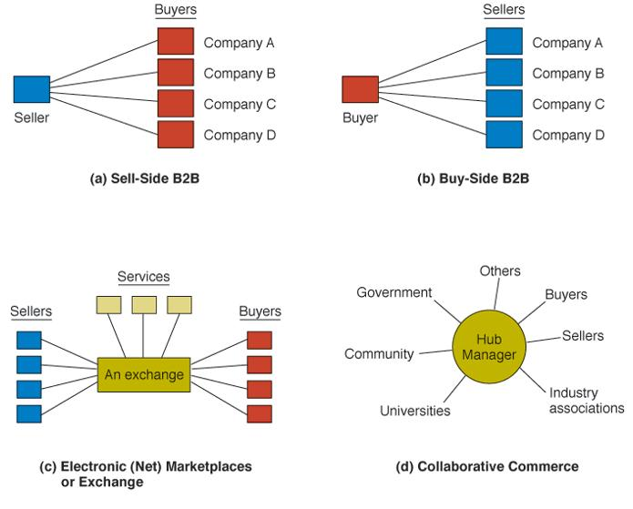
4.3 Types of B2B E-Commerce

4.31 Sell-Side B2B Marketplace Architecture

4.32 Buy-Side B2B Market Architecture
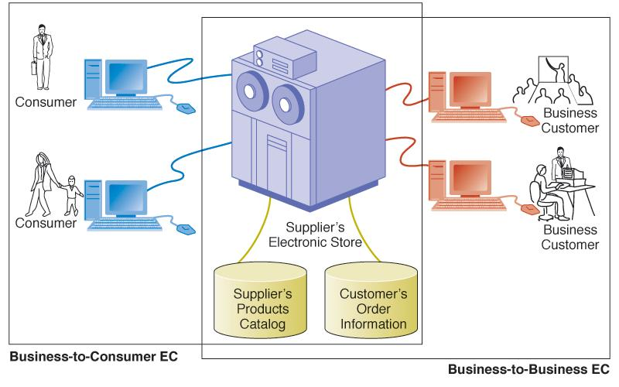

4.4 Barriers to C-Commerce
C-commerce –collaborative commerce is moving ahead fairly slowly because:
1. Technical reasons involving integration, standards, and networks
2. Security and privacy concerns over who has access control of information stored in a partner’s database
3. Internal resistance to new models and approaches
4. Lack of internal skills to conduct c-commerce
4.5 Infrastructure for B2B
B2B requires the following infrastructure for it to function:
1. Server to host database and applications
2. Software for executing sell-side (catalogs)
3. Software for conducting auctions and reverse auctions
4. Software for e-procurement (buy-side)
5. Security hardware and software
6. Software for building a storefront
7. Software for building exchanges
8. Telecommunications networks and protocols
4.6 Extranet and EDI
Traditional electronic data interchange systems were implemented using value-added networks. VANs are private, third-party-managed networks that add communications services and security to existing common carriers. EDI that runs on the Internet, that is, Internet-based EDI is the most widely used today mainly due to its accessibility and affordability to most companies.
Extranets—secured networks (by VPN), usually Internet-based, that allow business partners to access portions of each other’s intranets; “extended intranets.”
4.7 Integration
Integrating computer systems together has always been a tricky non-trivial task, usually fraught with problems and always involving great expense. In fact, it is one of the reasons why most businesses have not been able to implement EDI systems. Although there are vendor provided tools the process of integration is still a challenge to many organizations.
There are some considerations that one ought to make while integrating the EDI system with other existing information systems or with other business partners EDI system.
4.71 Integration with existing information systems issues
While integrating our EDI system with existing information system, we need to consider the following issues:
1. Intranet-based work flow
2. Database management systems (DMBS)
3. Application packages
4. ERP
4.72 Integration with business partners
Integration with one company is easy. When you are integrating your organizations system with those of sellers or buyers, the considerations may be the same as above but certainly the amount of work to be done is much more. This is because each system might be unique hence demanding a unique solution. Further consideration needs to be made for the buyer’s owned shopping cart .An important question is whether it will be able to interface with back-end information systems.
Some of the problems associated with integration may be solved by use of XML-the eXtensible Markup Languge.
4.8 The Role of XML in B2B Integration
Companies interact easily and effectively by connecting to their servers, applications, and databases. For these connections to work there must be standard protocols and data- representation schemes. The web is based on the standard communication protocols such as HTTP which are useful only for displaying static visual Web pages. XML (and its variants) is a standard that is used to improve compatibility between the disparate systems of business partners by defining the meaning of data in business documents.
It is used to increase:
1. Interactivity
2. Accessibility with speech recognition systems.
4.9 The Role of Software Agents
Software Agent’s may be used to in B2C comparison-shopping And in B2B agents collect information from sellers’ sites for buyers.
4.10 Agent’s role in the buy-side marketplace
In buy side market place, agents are used to assisting large number of buyers in requesting quotes from multiple potential suppliers in buy-side sellers.
4.11 Exercise:
1. Describe B2B and list four of its characteristics.
2. Use diagrams to explain four types of B2B E-commerce.
3. List four barriers to c-commerce.
4. What consideration would you make while integrating EDI systems with existing
information systems?
5. Why do most businesses shy away from implementing EDI systems?
6. Briefly explain the role of XML in integration.

Web Commerce Infrastructure

Commercial Websites .................................................................................................. 1
Components of a Well-Functioning Commercial Website .................................... 1
1. A well organized collection of products and/or services.......................... 1
2. A convenient way for a costumer to select products.................................. 1
3. Convenient order forms.................................................................................. 1
4. Convenient ways of payment ........................................................................ 2
5. Secure communication system....................................................................... 2
6. A way of storing information about customers........................................... 2
7. A way of keeping information about orders................................................ 2
8. Customer support and feedback ................................................................... 2
Technologies Used To Implement Above Features ................................................ 2
Three-Tier (Layer) Architecture for E-Commerce................................................... 3
1. Data Services Layer.......................................................................................... 3
2. Business Services Layer................................................................................... 3
3. Presentation Services Layer............................................................................ 3
Fig. 1: E-commerce three-tier system architecture .............................................. 4
Exercise: .......................................................................................................... 4

Commercial Websites
A commercial website is a website that offers products and /or services for sale. One of the major factors to the success of such a web site is attractiveness. However, even the most attractive web pages will not make a person come back to a website where it takes too long to find the right product or where order forms don’t work.
Components of a Well-Functioning Commercial Website
The most important elements of a good website are:
- A well organized collection of products and/or services
There should be a way for customers to get all the necessary information about products, compare several products, and get advice on related products e.t.c Changes in product information must avoid inconsistencies. Such changes should reflect on every day’s availability, change in price, product cross-references e.t.c
- A convenient way for a costumer to select products
This can be implemented using a shopping cart or basket. The customer should be able to select and delete products while browsing.
- Convenient order forms
An order form should have as few fields as possible and a returning customer should be provided with default information so as to reduce on the amount of entries he/she needs to make. The form should also catch simple typographical errors.
- Convenient ways of payment
Many options for effecting payment should be provided. There should be a quick way to verify the payment commitment, to check if they are valid, for the owner of the site.
- Secure communication system
This protects transmission of payment information and guarantees privacy of the customer. It also prevents unauthorized access to the site.
- A way of storing information about customers
A well functioning commercial website should avoid re-entry of some information by customers. It should allow customizing of the website to fit someone’s interest. This is achieved via customer registration or “cookies”.
Benefits of this to the owner
Enables the owner to customize advertisements based on customer profiles or send emails advertising a new product.
Ability to monitor customer behavior
- A way of keeping information about orders
A commercial website should allow customers to track their orders and owners to get all kinds of financial and statistical information.
- Customer support and feedback
This aspect cannot be completely mechanized. A human being has to answer e-mails, judge tolerance of customer’s comments, organize comments by topics e.t.c
Customer support and feedback is achieved through online documentation of all products, FAQs, and a way for customers to post their opinion.

NB: The above mostly address B2C. For B2B, sites have to be optimized if a company has stable business partners.

Technologies Used To Implement Above Features
1). A database implements convenient storage of information about products.
Databases may be implemented using database management systems [DBMSs] like Oracle, Ms Access, and MS SQL. This applies for (6), (7) and (8).
2). A convenient interface to the database is provided through the website and implemented through HTML, Java or JavaScript and PHP. We can use ODBC or JDBC to connect remotely to databases
3).Ability to process forms is through various server-site scripts such as Common Gateway Interface -CGI, PERL, Asp or Java Servelets.
4). Cookies are used to keep track of a user during a session. A cookie is a small text file placed by a web server on the client machine and gets sent back every time the client requests a web page from the server. It is implemented through Java Servelets, Asp e.t.c
5). Encryption and security is implemented via secure sockets layer (SSL).
6). Electronic payment systems and credit card payment methods are used for payment options

Three-Tier (Layer) Architecture for E-Commerce
E-commerce systems can be implemented using a multi-tier architecture consisting of three tiers or layers. In a typical three-tier architecture (see Fig. 1) for e-commerce systems, the first tier is the data services layer; the second tier is the business services layer, while the third tier is the presentation services layer.
1.Data Services Layer
The underlying technology to implement this layer could be a variety of things, including client side cookies, server-side files or a database. This layer is usually best satisfied with a database, running either on the web server itself or easily accessible to the web server, that is in the database server.
2.Business Services Layer
This layer consists of business and data components and is composed of a web server running a simple language providing database access. The business components assist in handling business
processes/operations while data components provide database access and hide underlying database structure.
In this layer, where you code any rules regarding the data you have stored and generally is the bulk of your system. This layer representing the middleware of the integrated system is implemented through a variety of middleware technologies including Common Gateway Interface (CGI) scripts and Java Servelets. Data components hide the underlying data structure from clients
3.Presentation Services Layer
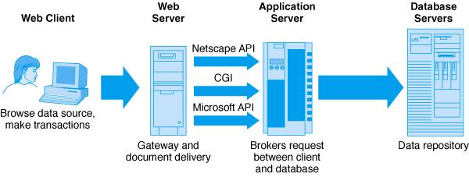
This layer is the application or user-agent (such as a browser) rendering the output of your markup or scripting code for your users. Through the very nature of the Internet, this tier’s processing is distributed to many computers browsing your site. This layer enables users to see results of your business logic applied to the data you have stored. Provides the user interface to system and converts input data to a format that can be understood at business layer and vice-versa.

Fig. 1: E-commerce three-tier system architecture

Exercise:
1. Create a simple Database for recording data about customers, and a web page
which should allow the customer to enter his/her details remotely.
2. Describe the term commercial website.
3. Briefly explain five components of a well functioning commercial website.
4. Describe the technology that can be used to implement the above components.
5. Use a diagram to describe the three tier architecture for E-commerce.

Shopping Cart Fundamentals
Chapter 6: Shopping Cart Fundamentals..................................................................... 1
6.0 Introduction ............................................................................................................ 1
6.1 Operation of shopping Cart.................................................................................. 1
6.2 Checkout process ................................................................................................... 1
6.3 Information Architecture of the shopping cart:................................................. 2
6.4 Principles for designing the information architecture of the shopping cart
and checkout processes ............................................................................................... 2
6.5 Implementing a Simple Shopping Cart Application ........................................ 4
6.6 Overview of Server-Side Scripting and Active Server Pages (Asp) ............... 4
6.7 Invoking ASP.......................................................................................................... 4
6.8 Differences between Client-side and Server-side Scripts................................. 4
6.9 Example .......................................................................................................... 5
Collections ............................................................................................................... 6
Example .................................................................................................................. 6
6.10 Explanation of Example ...................................................................................... 7
6.11 Exercise: .......................................................................................................... 8

6.0 Introduction
A shopping cart is an e-commerce ordering system. It is also called a wheelbarrow, shopping bag or a shopping basket.
6.1 Operation of shopping Cart
Users initially go to a website and look for the products and/or services they need, thereafter they can click on or “tag” items of interest for later purchase.
This process is called “adding up” items for purchase to a “Shopping cart”. The concept (Metaphorically) of a shopping cart helps users understand the actions available to them including:
i.Adding additional items to their purchase list
ii.Deleting items they selected and
iii.Adjusting the quantity of each item to purchase.
Metaphors such as wheelbarrow, shopping bag, shopping basket can also be used to refer to this technology. They provide creative ways of giving users a mental mode for shopping online.
6.2 Checkout process
When users finish shopping, they proceed to this process to provide their address and payment information.
Checkout process may include:
i.Specifying a shipping preference
ii.Shipping address
iii.Method of payment and
iv.Any gift-wrapping preferences.
6.3 Information Architecture of the shopping cart:
Information architecture refers to the method of structuring and organizing information environments to help people achieve their goals. Information architecture of the shopping cart depends on, clear organization, labeling, navigation and searching systems.

6.4 Principles for designing the information architecture of the shopping cart and checkout processes
These principles aim at providing a foundation for rich functionality of e-commerce systems. They include:
6.4.1 Shopping cart process
1. Make the shopping cart easy to find
2. Provide clear ordering options
3. Provide for rich functionality of the shopping cart
4. Make related items available for the shopping cart
5. Provide for the items in the shopping cart to be saved for future purchase
6.4.2 Checkout process
1. Give advance notice of what the checkout process involves
2. Keep order forms simple
3. Ensure secure transactions.
1. Making it easy to find
Users should be able to begin ordering process once they have located the items they want.
There should be multiple entry points to the cart from the site and for each item in the shopping cart users should see the following information at a glance:
i.Description of item.
ii.Option to remove or add item
iii.Option to add item to shopping list for future purchase
iv.Items current availability
2. Provide clear ordering options
Provide clear distinction between different ordering options. New ordering options help users’ process orders quickly, but may often confuse or slow down users.
3. Provide rich functionality
These include:
i. Options to add items
ii. Remove items
iii. Find out more information
Users should be able to add items during the shopping process or to easily return to shopping in the site after adding an item to the cart. The system should provide appropriate navigational links and options to easily modify quantity of each item or remove items. It should also provide links from each item back to the detailed description for that item.
- Make related items available
The e-commerce system should be able to gather user information about past purchases and come up with trends. It should be able to associate items with related items and make this information available to the shopping cart.
This can help increase sales
- Save items for future purchase
The system should enable comparison-shopping as well as people purchasing when there is money. Most sites implement this as wish or shopping lists.
- Provide advanced notice
In order to give users an advance notice of what the checkout process involves the system should:
❍ Let the users know in advance what they can expect in the checkout
process e.g. shipping costs
❍ Provide the users with clues as to where they are in the ordering process
e.g. show steps completed and those left
❍ Also provide users upfront with the information they need to make their
decisions to complete the purchase (e.g. costs of shipping options
available)
- Keep order forms simple
Order forms should be as simple as possible to help users complete them quickly and without confusion but should have the necessary functionality to meet a users needs. They should indicate required fields as well as optional ones (these can be eliminated). The order process should give the user an opportunity to confirm that all the information is correct before submitting his/her order. While designing the order forms one should have in mind an international audience.
- Ensure secure transactions
To address users concerns about security;
❍ Have an established brand, provide secure web servers and processes and
provide a satisfaction warranty.
❍ Provide information about security and safety of purchases.
❍ Enforce trust as a user goes through the checkout process e.g enable user to
call with credit card number or mail a personal check instead of filling
details in a form
❍ Also provide order confirmations and e-mail customers to further establish
user’s trust. You could also send an e-mail message at the time the user’s
order is shipped.
❍ Provide FAQs, email address for questions and phone number for customer
representative, to help address problems encountered by users.

6.5 Implementing a Simple Shopping Cart Application
A shopping cart is best implemented using databases and database connectivity tools e.g. php, asp e.t.c. A database is a special kind of file that stores data and allows updates and modifications in a uniformed way. SQL is the language used to interact with databases. It allows you to create, delete and update records and connects to databases using middleware such as ODBC, JDBC e.t.c.
6.6 Overview of Server-Side Scripting and Active Server Pages (Asp)
ASP refers to pages that are processed on the server, while the results are displayed on the client. ASP code can be written in JavaScript, JSP, or VBScript.
The default script language used by ASP is VBScript. This can however be changed by use of a simple tag whose format is: <%@ language=value %>
6.6.1 Advantages of Server-Side Programming/Scripting
- Can tailor output to particular browsers
- Easier to achieve portability and maintainability
6.62 Disadvantages of Server-Side Programming/Scripting
i.Security risk
❍ Easy to compromise host security
❍ Easy to allow users to do things that get you into trouble
ii.Problems with concurrency
❍ More people can hit your script at the same time?
❍ Easy to erase information inadvertently by misunderstanding
concurrency limits
6.7 Invoking ASP
When using ASP files are named in the format filename. asp. They are started by the markup tag: <%@ language=value %> where value is Jscript, JavaScript or VbScript.
Within the code there are several ways to invoke server side scripts i.e.
i.Within special script tags annotated with runat=server
<script language=Jscript runat=server>
Response. write(“<h2>Leah Kamunge Njiri</h2>”);
</script>
ii.Within special script tag <% …%>
<%
Response. write(“<h2>Leah Kamunge Njiri</h2>”);
%>
6.8 Differences between Client-side and Server-side Scripts
1. The browser never sees the server-side script-it only sees the output
2. Server-side script operation cannot be overridden by user actions- client-side
scripts can be disabled under user control
3. Server-side scripts have full power to manipulate files on host machine
4. Server-side scripts can keep records and remember user preferences- utilized
to implement cookies
5. Server-side scripts include new objects e.g.
(a) Request which represents data sent to server from browser e.g. CGI
parameters (form values and URL parameters), cookies e.t.c.
(b) Response which represents document to be sent to browser
6. There is no document object since we are on the server
7. There is no access to window object for server-side scripts

6.9 Example
Write a CGI script that gets values from a form and prints out those values as a
web page.
Solution: we write an html page to give form structure then an asp file to process
the form.
form_submit.html
<html><body bgcolor="pink">
<h4 align=center>Please tell me about yourself</h4>
<form action="form_values.asp" method="post" target="_blank">
<center><table border=20 bgcolor="biege">
<tr><th>Name<td><input type="text" name="names">
<tr><th>Postal Address<td><input type="text" name="postal">
<tr><th>Physical Address<td><input type="text" name="location">
<tr><th>Country<td><select name="country">
<option value="Kenya" selected>Kenya</option>
<option value="Uganda">Uganda</option>
<option value="Tanzania">Tanzania</option></select>
<tr><th>Gender
<td><input type="radio" name="gender" value="Male">Male&nbsp;
<input type="radio" name="gender" value="Female">Female&nbsp;
<input type="radio" name="gender" value="Non of the above">None
<tr><th>Email Address
<td><input type="text" name="email">
<tr><td><input type="submit" value="Send Details">
<td><input type="reset" value="Clear">
</table></center></form></body></html>
form_values.asp
<%@ language=JScript%>
<html><body><h4 align=center>Here is what you submitted</h4>
<center><table bgcolor="pink" border=20 width="100%">
<%
name=Request.Form('names');
postal=Request.Form('postal');
location=Request.Form('location');
country=Request.Form('country');
gender=Request.Form('gender');
email=Request.Form('email');
Response.write("<tr><th>Name<td>"+name+"</tr>");
Response.write("<tr><th>Postal Address<td>"+postal+"</tr>");
Response.write("<tr><th>Physical Address<td>"+location+"</tr>");
Response.write("<tr><th>Country<td>"+country+"</tr>");
Response.write("<tr><th>Gender<td>"+gender+"</tr>");
Response.write("<tr><th>Email Address<td><a
href='mailto:"+email+"'>"+email+"</a></tr>");
%>
</table></center></body></html>
Collections
❍ Un-exposed ordered arrays, which can be accessed using indices
❍ Can also be accessed using enumerators- objects designed to process data in
sequence
Example
form_enum.html
<html><body bgcolor="pink">
<h4 align=center>Please tell me about yourself</h4>
<form action="form_enum.asp" method="post" target="_blank">
<center><table border=20 bgcolor="biege">
<tr><th>Name<td><input type="text" name="names">
<tr><th>Postal Address<td><input type="text" name="postal">
<tr><th>Physical Address<td><input type="text" name="location">
<tr><th>Country<td><select name="country">
<option value="Kenya" selected>Kenya</option>
<option value="Uganda">Uganda</option>
<option value="Tanzania">Tanzania</option>
</select>
<tr><th>Gender<td><input type="radio" name="gender"
value="Male">Male&nbsp;
<input type="radio" name="gender" value="Female">Female&nbsp;
<input type="radio" name="gender" value="Non of the above">None
<tr><th>Email Address<td><input type="text" name="email">
<tr><td><input type="submit" value="Send Details">
<td><input type="reset"
value="Clear"></table></center></form></body></html>
form_enum.asp
<%@ language=JScript%>
<html><body background="Tapi.jpg">
<h4 align=center>Here is what you submitted</h4>
<center><table bgcolor="pink" border=20 width="100%">
<%
var en=new Enumerator(Request.Form);//creates an object en
for(en.moveFirst();!en.atEnd();en.moveNext())

6

{//for all members or form fields
var field=en.item();//get one field
var value=Request.Form(field);//get field's value
Response.write('<tr><th>'+field);
Response.write('<td>'+value);
}
%></table></center></body></html>
6.10 Explanation of Example
❍ en is an enumerator object that enables you to access elements of a
collection.
❍ item() is a method and en.item() accesses the current item or element
❍ en.moveFirst() sets en.item() as the first item/element.
❍ en.moveNext() makes en.item() the next item in the sequence
❍ en.atEnd() is true when we have no more items, is false otherwise.
Connecting to a Database
<%
var con=Server.CreateObject(“ADODB.Connection”);
con.Open(“myData”);
var name=Request.Form(‘name’);
var salary=Request.Form(‘salary’);
var email=Request.Form(‘email’);
var command=”insert into Mimi values(‘”+name+” ‘,’ “+email+” ‘, “+salary+”)”;
con.Execute(command);
%>
NB:
❍ We call the above using a form
❍ Strings must be single quoted
❍ Numbers must not be quoted
Select and Display Records from a Database Table
select.asp
<%@ language=JScript%>
<html><body><h2>Reading from a table</h2>
<%
var con=Server.CreateObject(“ADODB.Connection”);//create a connection
object
con.Open(“myData”);//create a connection
var command=”select * from Mimi”;//select all records
var recordset=con.Execute(command);//retrieve records
Response.write(“<table border=’”+1+’”+”>”);
Response. Write(“<tr><th>Name<th>E-mail<th>Salary”):
for(recordset.moveFirst();!recordset.EOF;recordset.moveNext())
{
var name=recordset.Fields(0).Value;
}
var email=recordset.Fields(1).Value;
var salary=recordset.Fields(2).Value;
Response.write(“<tr><td>”+name+”<td>”+email”+”<td>”+salary);
Response.write(“</table>”);
%>
</body></html>
Note:
❍ Recordset is an enumerable collection i.e. it has its own enumerator
❍ recordset.Fields(0).Value is first field of first row

6.11 Exercise:
1. Define the term shopping cart and enlist the actions it makes available to
the user?
2. Explain briefly the checkout process.
3. Describe the principles for designing the information architecture of the
shopping cart and the checkout processes.
4. Briefly describe the following terms and state where they may be applied
in the development of a shopping cart.
a. Database
b. JavaScript
c. Jscript
d. SQL
e. ASP
f. JDBC
g. CGI
5. Write a CGI script that gets the values [Name, Country and email] from a
form and prints out those values as a web page. NB: This requires that
you create a HTML file and an ASP file

